Maximum marks for Assignment: _9_ Assignment Declaration Date: 24/9/2025
Assignment Submission Date: 30/9/2025 Assignment assessment declaration Date by faculty: 30/9/2025

Question NO | Question Statement | Level of mapping & NO. |  |  | Blooms Level | Mark
Question NO | Question Statement | CO | PO | PSO | Blooms Level | Mark
Q1. | What is Deadlock? Explain the Necessary condition for deadlock. | CO5 | PO1 |  | 1 | 6
Q.2 | Explain Bankers Algorithm, Apply the Algorithm for the following example, and show the results: maximum resources [7 7 10]  Request Allocation  3 6 8 2 2 3  4 3 3 2 0 3  3 4 4 1 2 4 | CO5 | PO3 |  | 3 | 4
Q.3 | What is the difference between deadlock avoidance and prevention? | CO5 | PO2 |  | 2 | 6
Q.4 | What is an operating system? What are the basic services and functions of an operating system? | CO5 | PO1 |  | 2 | 5
Q.5 | Explain inter-process communication. Explain different IPC problems. | CO5 | PO1 |  | 2 | 4
Q.6 | Explain the concept of a semaphore and its practical use of semaphore. | CO5 | PO1 |  | 2 | 4
Q.7 | Explain the Consumer problem & Dining Philosopher problem with a solution? | CO5 | PO1 |  | 2 | 5
Q.8 | Write a solution to the Reader-Writer problem using Semaphores with readers having priority. | CO5 | PO1 |  | 3 | 6
Q.9 | Explain the concept of race conditions. How to handle it | CO5 | PO1 |  | 2 | 5
Q.10 | Explain the Mutual exclusion hardware and software approach in detail, with advantages and disadvantages. | CO5 | PO1 |  | 2 | 6
Q.11 | Write a short note on the following with an example.  i) Semaphore ii) Monitor iii) Mutex | CO5 | PO1 |  | 1 | 6
Q.12 | Explain Deadlock prevention, deadlock avoidance, deadlock detection, and deadlock recovery with examples | CO5 | PO1 |  | 2 | 9
Blooms level no | Blooms Taxonomy terms
6 | 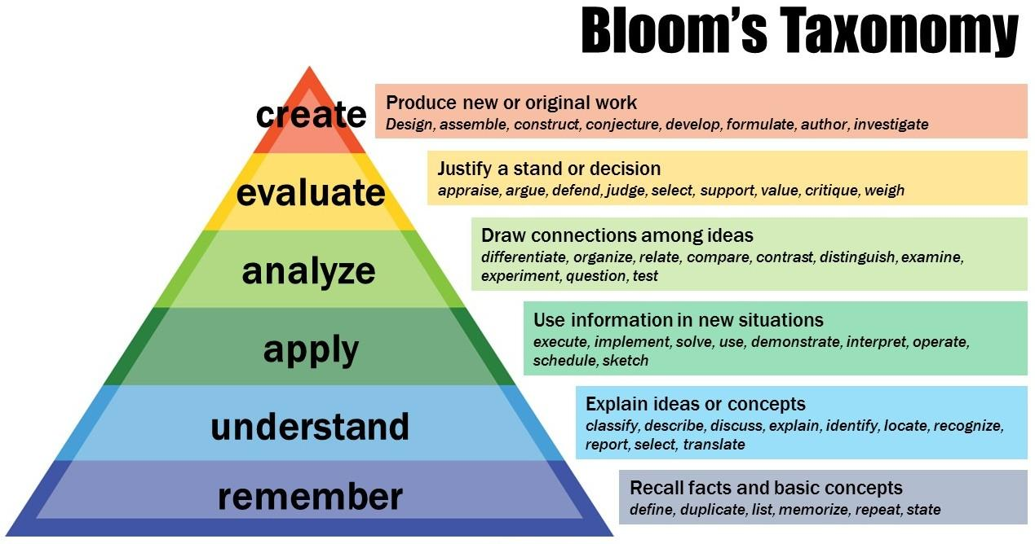
5
4
3
2
1

Subject In-charge HOD

